Division of Africa due to the Berlin Conference (1884-5)

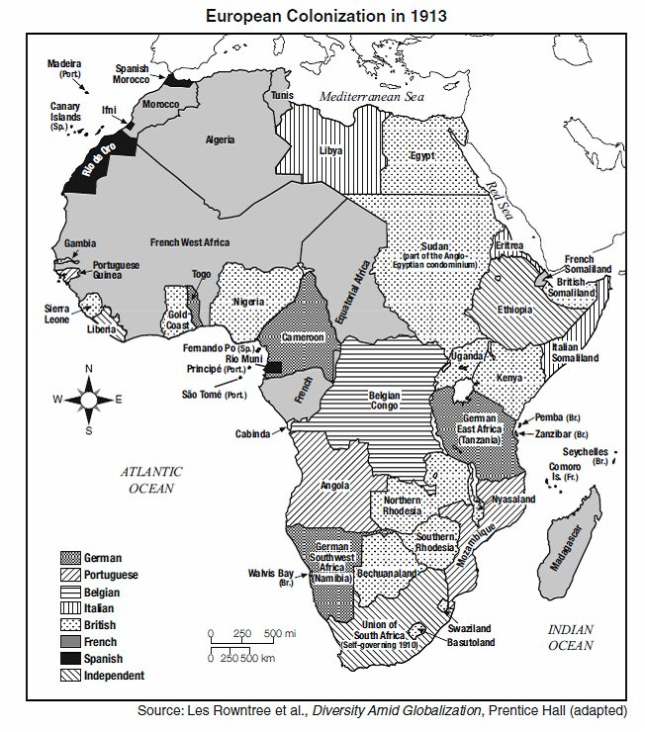

Division of Africa due to the Berlin Conference (1884-5)

